SURE TRUST

G5-Cybersecutity And Ethical Hacking

Final Project

By:SUFIYA HAFIZ

**Level 1**

Explanation:

Inject a script to popup a javascript alert() in the frame. Now type <script>alert(1)</script> and you will see that there is no encoding happening and the popup gets triggered.

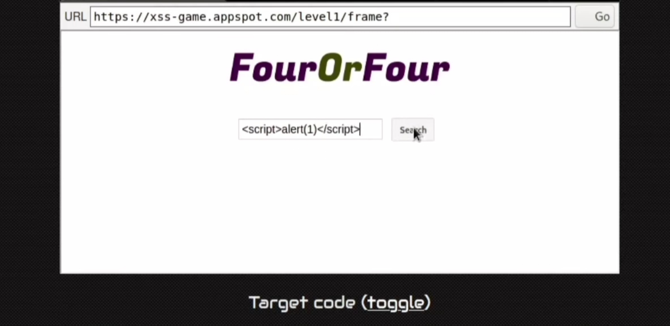

**Output**

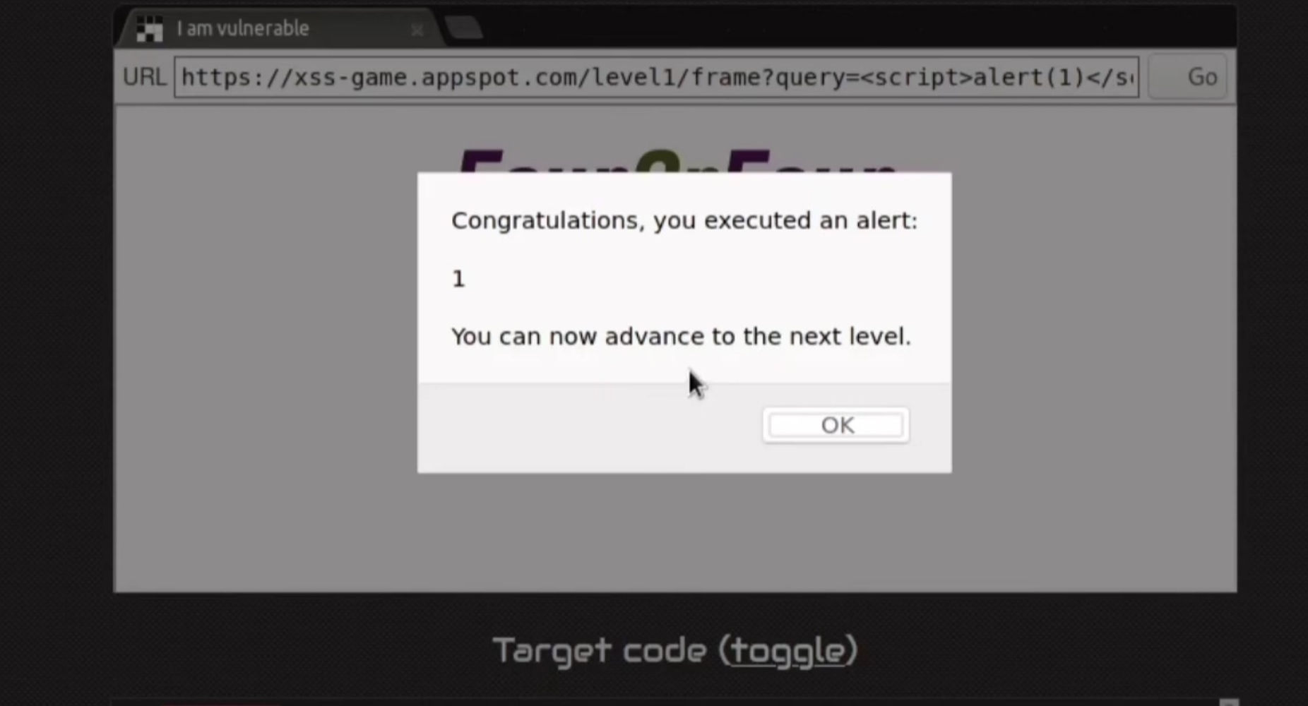

**Level 2**

Explanation:

Inject a script to popup a javascript alert() in the frame. Now type <img src=”x” onerror=alert(1)> and you will see that there is no encoding happening and the popup gets triggered.

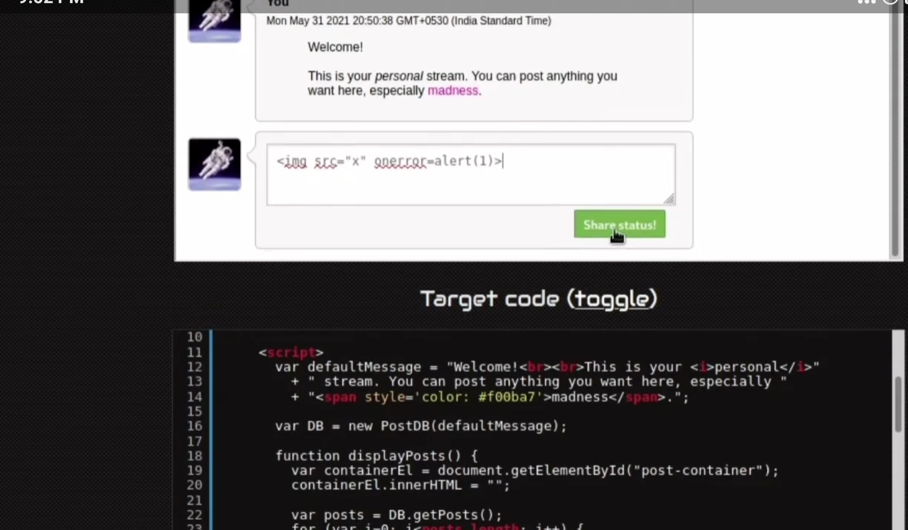

**Output**

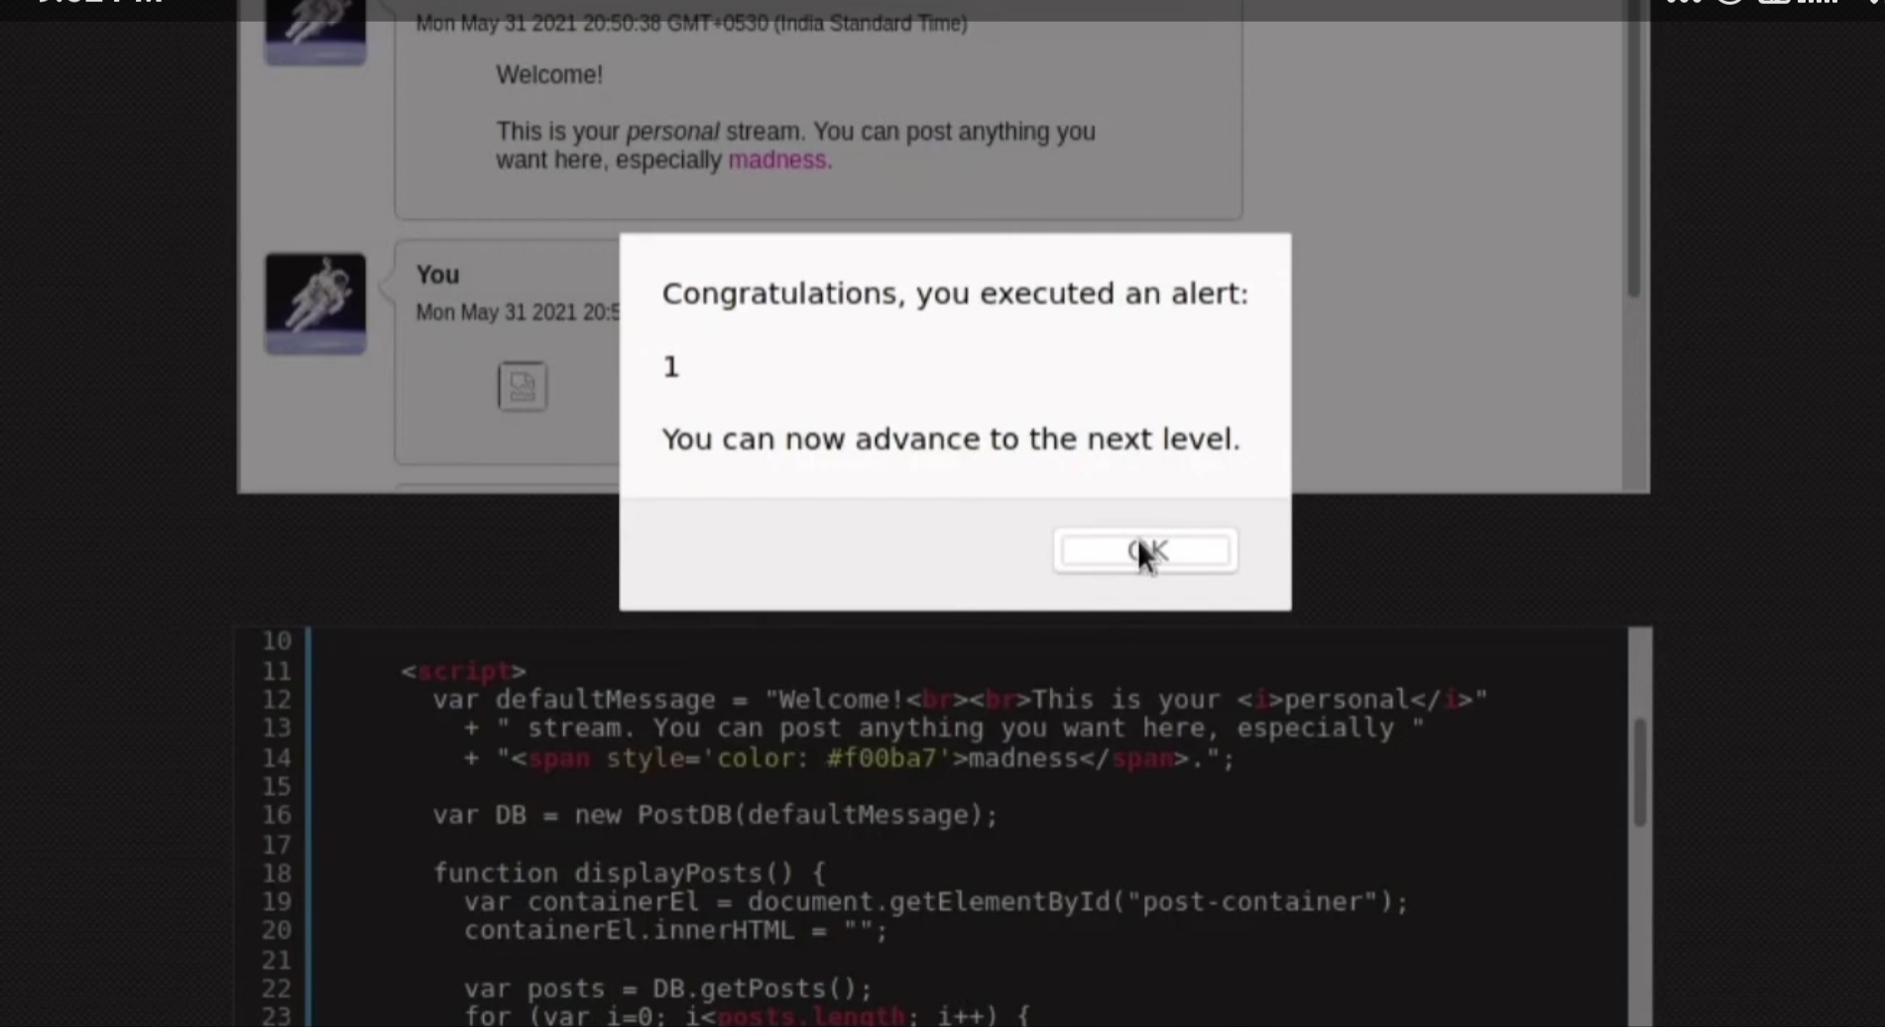

**Level 3**

Explanation:Inject a script to popup a javascript alert() in the frame. Now type #3’ onclick=”alert(1)” ‘ and you will see that there is an image displayed followed by popup alert message.The page will try to load the image from the source ‘1’ which will fail miserably and then trigger the onerror attribute’s code.

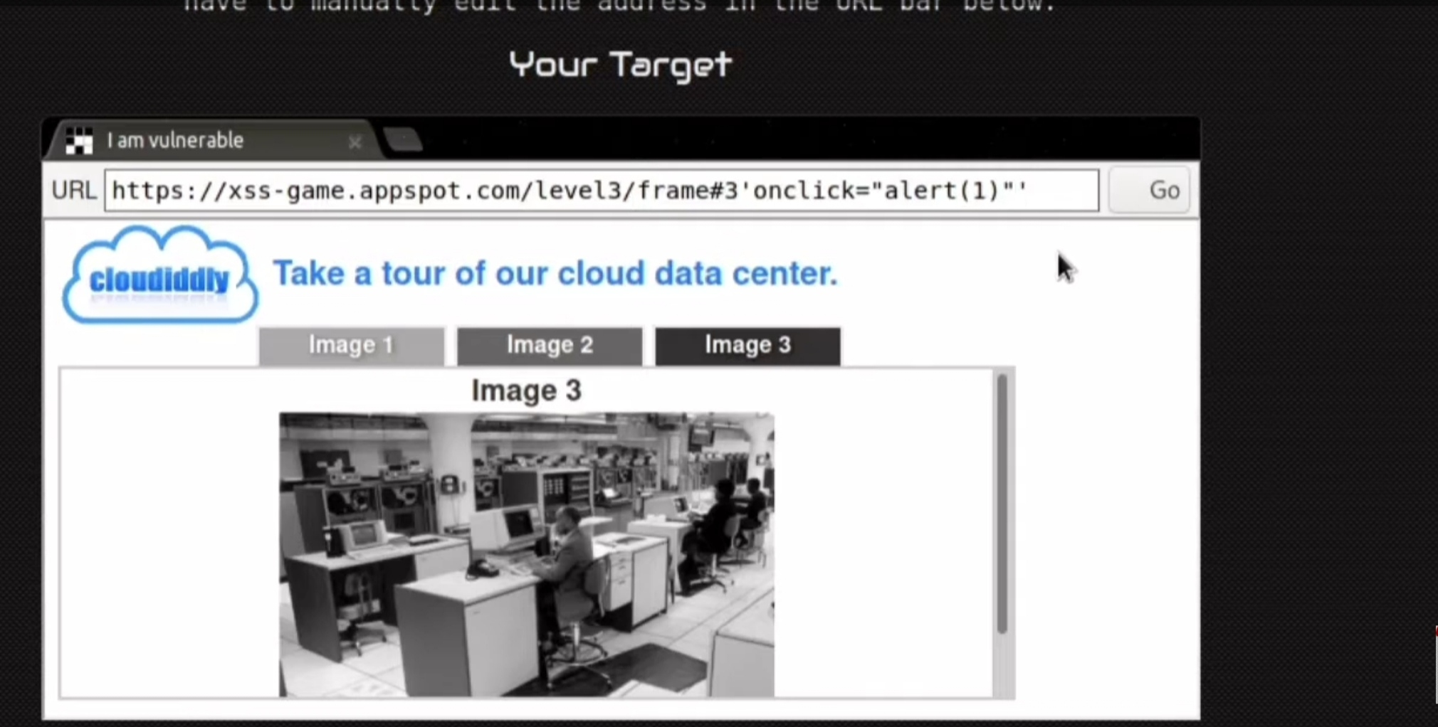

**Output**

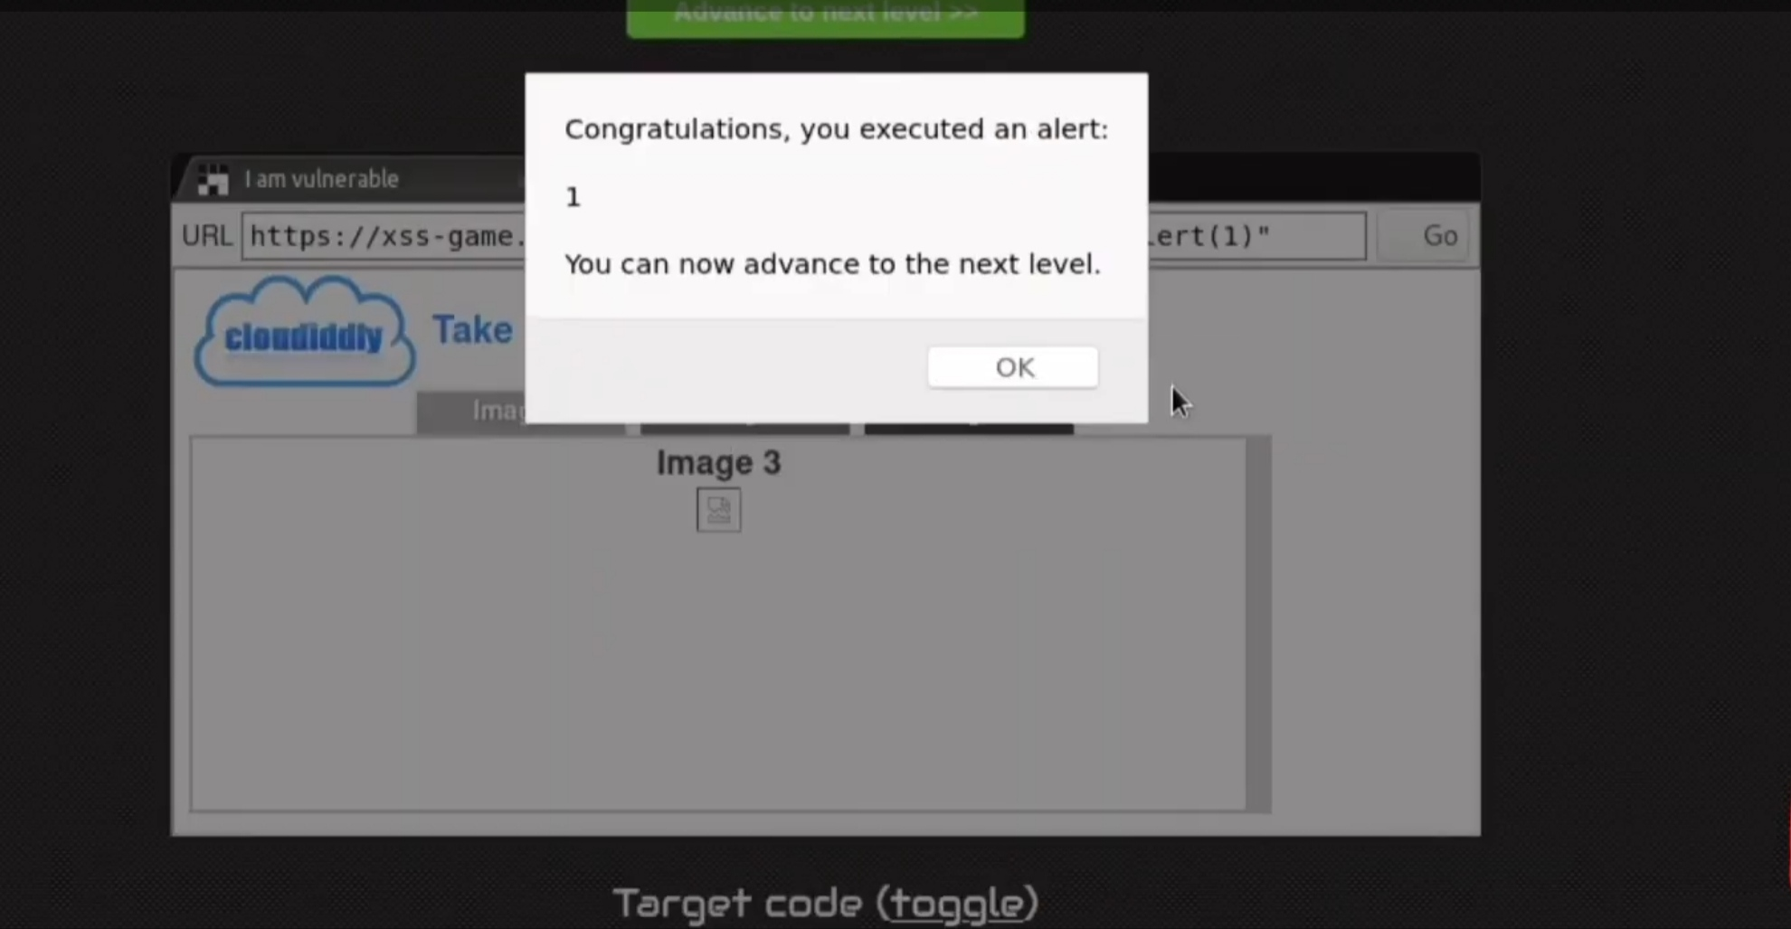

**Level 4**

Explanation:The value we passed by the index page is straightly added into the function parameter at the timer. The Javascript will try to evaluate time=3 before it calls the start timer function. To evaluate the result of time=3 it needs to get the value returned by the function alert(), which will make the browser execute the alert function.

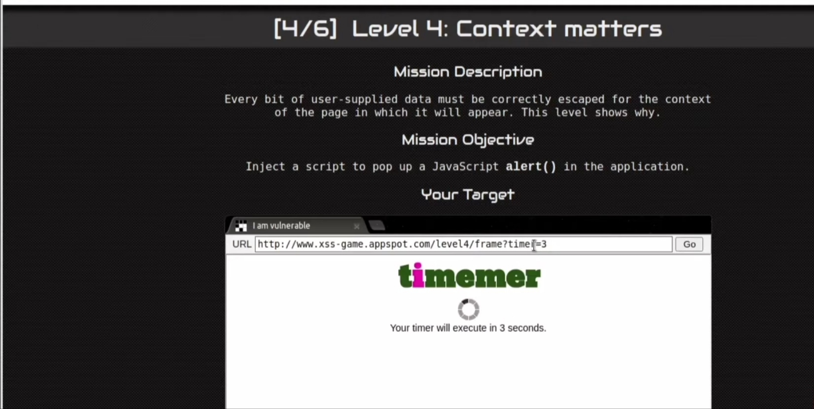

**Output**

